**Maces and Talons**

Final Report for CS39440 Major Project

*Author*: Callum Gwynedd Hay Hutchinson ([cgh2@aber.ac.uk](mailto:cgh2@aber.ac.uk))

*Supervisor*: Dr Bernie Tiddeman (bpt@aber.ac.uk)

16th April 2018

Version 1.0 (Draft)

This report is submitted as partial fulfilment of a BSc degree in  
Computer Science including Integrated Industrial and Professional Training (G401)

Department of Computer Science

Aberystwyth University

Aberystwyth

Ceredigion

SY23 3DB

Wales, UK

**Declaration of originality**

I confirm that:

* This submission is my own work, except where clearly indicated.
* I understand that there are severe penalties for Unacceptable Academic Practice, which can lead to loss of marks or even the withholding of a degree.
* I have read the regulations on Unacceptable Academic Practice from the University’s Academic Quality and Records Office (AQRO) and the relevant sections of the current Student Handbook of the Department of Computer Science.
* In submitting this work I understand and agree to abide by the University’s regulations governing these issues.

Name …………………………………………

Date ……………………………………………

**Consent to share this work**

By including my name below, I hereby agree to this dissertation being made available to other students and academic staff of the Aberystwyth Computer Science Department.

Name …………………………………………

Date ……………………………………………

**Acknowledgements**

I am grateful to…

I’d like to thank…

**Abstract**

This aim of this project was to produce a video game representation of the medieval Scandinavian board game Hnefatafl, providing single device and online multiplayer support.

**Contents**

1. Background, Analysis & Process 7

1.1. Background 567 7

1.1.1. Similar Systems 953 9

1.1.2. Development Research 762 13

1.2. Analysis 463 15

1.2.1. Requirements 511 16

1.3. Process 290 17

2. Design 18

2.1. Overall Architecture 18

2.2. Detailed Design 18

2.2.1. Game Client 18

2.2.2. Server Application 18

2.2.3. Network Code 18

2.3. User Interface Design 20

2.4. Other Relevant Sections 20

3. Implementation 22

3.1. Game Client 22

3.1.1. Game generation 22

3.1.2. Taking pieces 22

3.2. Multiplayer Server 23

3.3. Network Code 23

3.3.1. Asynchronous Connection 23

3.3.2. Network Message 23

3.4. Server Hosting 23

4. Testing 24

4.1. Overall Approach to Testing 24

4.2. Automated Testing 24

4.2.1. Unit Tests 24

4.2.2. User Interface Testing 24

4.2.3. Stress Testing 24

4.2.4. Other Types of Testing 24

4.3. Integration Testing 24

4.4. User Testing 24

5. Critical Evaluation 25

5.1. Research 25

5.2. Requirements 25

5.3. Design Decisions 25

5.4. Tools 151 25

5.5. Future Work 25

5.5.1. Authoritative Server 25

5.5.2. Google Play integration 25

5.5.3. Online Lobby 25

5.5.4. 2D View 25

6. Appendices 26

A. Third-Party Code and Libraries 26

B. Ethics Submission 27

C. Code Samples 27

Annotated Bibliography 28

# Background, Analysis & Process 3546

## Background 567

The Project aims to create a video game based on the Scandinavian medieval board game ‘Hnefatafl’, this game would feature a single device two player hot seat mode and an online multiplayer mode.

Having previously developed two Android applications and several years of experience developing in Unity 3D, this project idea was interesting to me because I could use skills that I had learnt at University and skills developed in my spare time to produce my best game so far.

‘Hnefatafl’ is a variant of the larger game ‘Tafl’, Tafl is a board game in which two forces much like chess compete against each other to win, unlike chess the two sides are uneven and have different win conditions. As the board game moved around northern Europe different rulesets were developed and layouts to the board and pieces [5], ‘Hnefatafl’ which is the Scandinavian variety uses a board which is 11 squares by 11 squares (11x11) or less commonly 13x13, there are other known types such as ‘Ard-Ri’ and ‘Tawlbyund’ which use 7x7 and 11x11 respectively.

The two different board sizes for Hnefatafl also presents two different configurations for the pieces as shown in Fig 1, while the outside ‘Barbarian’ pieces remains the same the Vikings in the centre have a slightly different formation.

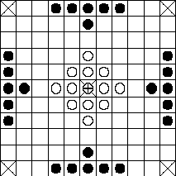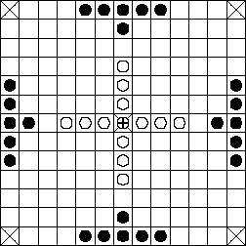

Figure ,[5] The two sizes of Hnefatafl board with the pieces arranged accordingly.

Due to time restrictions the Project just focuses on the more commonly used board size 11x11 and the corresponding piece layout, however there is the option to add the other size if time permits.

The rules of Hnefatafl are a lot simpler than those of chess, all pieces move in the same manner, in straight lines horizontally and vertically as far as they want until hitting an obstruction. This is much the same as a rook in chess except that you do not take a piece by going on to its space, pieces in Hnefatafl cannot pass through or go on to space occupied by another space, this allows for strategies that rely on blocking the opposing team off. To take a piece it must have two opposing pieces on two opposite sides, therefore creating a line of three, the taken piece is removed from the game. The one unique piece is the ‘King’ this is placed in the centre of the board and is surrounded by the ‘Knights’ or in the case of ‘Hnefatafl’ the ‘Vikings’, to take/capture the King it must be surrounded on all four sides by opposing pieces or edges of the game board. Fig 2 shows the different cases when the King could be taken, the difficulty of taking the King is made easier by the uneven numbers, the ‘Barbarians’ have almost double the number of pieces at 24 versus the ‘Viking’s’ 13.

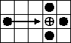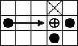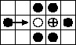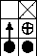

Figure , [5] All cases in which the King would be taken.

The objectives of both teams are different, the ‘Barbarian’s’ sole goal is to capture the King, theoretically this also could lead to them capturing all of the other Viking pieces but this is not necessary for them to win. The ‘Vikings’ must get their King to one of the 4 corners of the board to win, or capture all of the opposing ‘Barbarians’ but this is highly unlikely due to the imbalance in the two sides, this outcome would only happen if the person controlling the ‘Barbarians’ is very inexperienced.

### Similar Systems 953

There are several Android applications that are published on the ‘Google Play Store’ and emulate ‘Hnefatafl’, they provide features that the project aims to produce and this allows me to analyse them and see what works well and if anything can be improved. Due to the nature of the game, many of the features are similar in each version and most of these will be included but I will evaluate the importance of their completion in terms of development time.

#### Hnefatafl [2]

The first version that I looked at contains a mixture of features some that will not be included in the project, this version only contains offline modes, a ‘hot-seat’ mode as the project will contain and an offline AI mode against a varying difficulty of opponents.

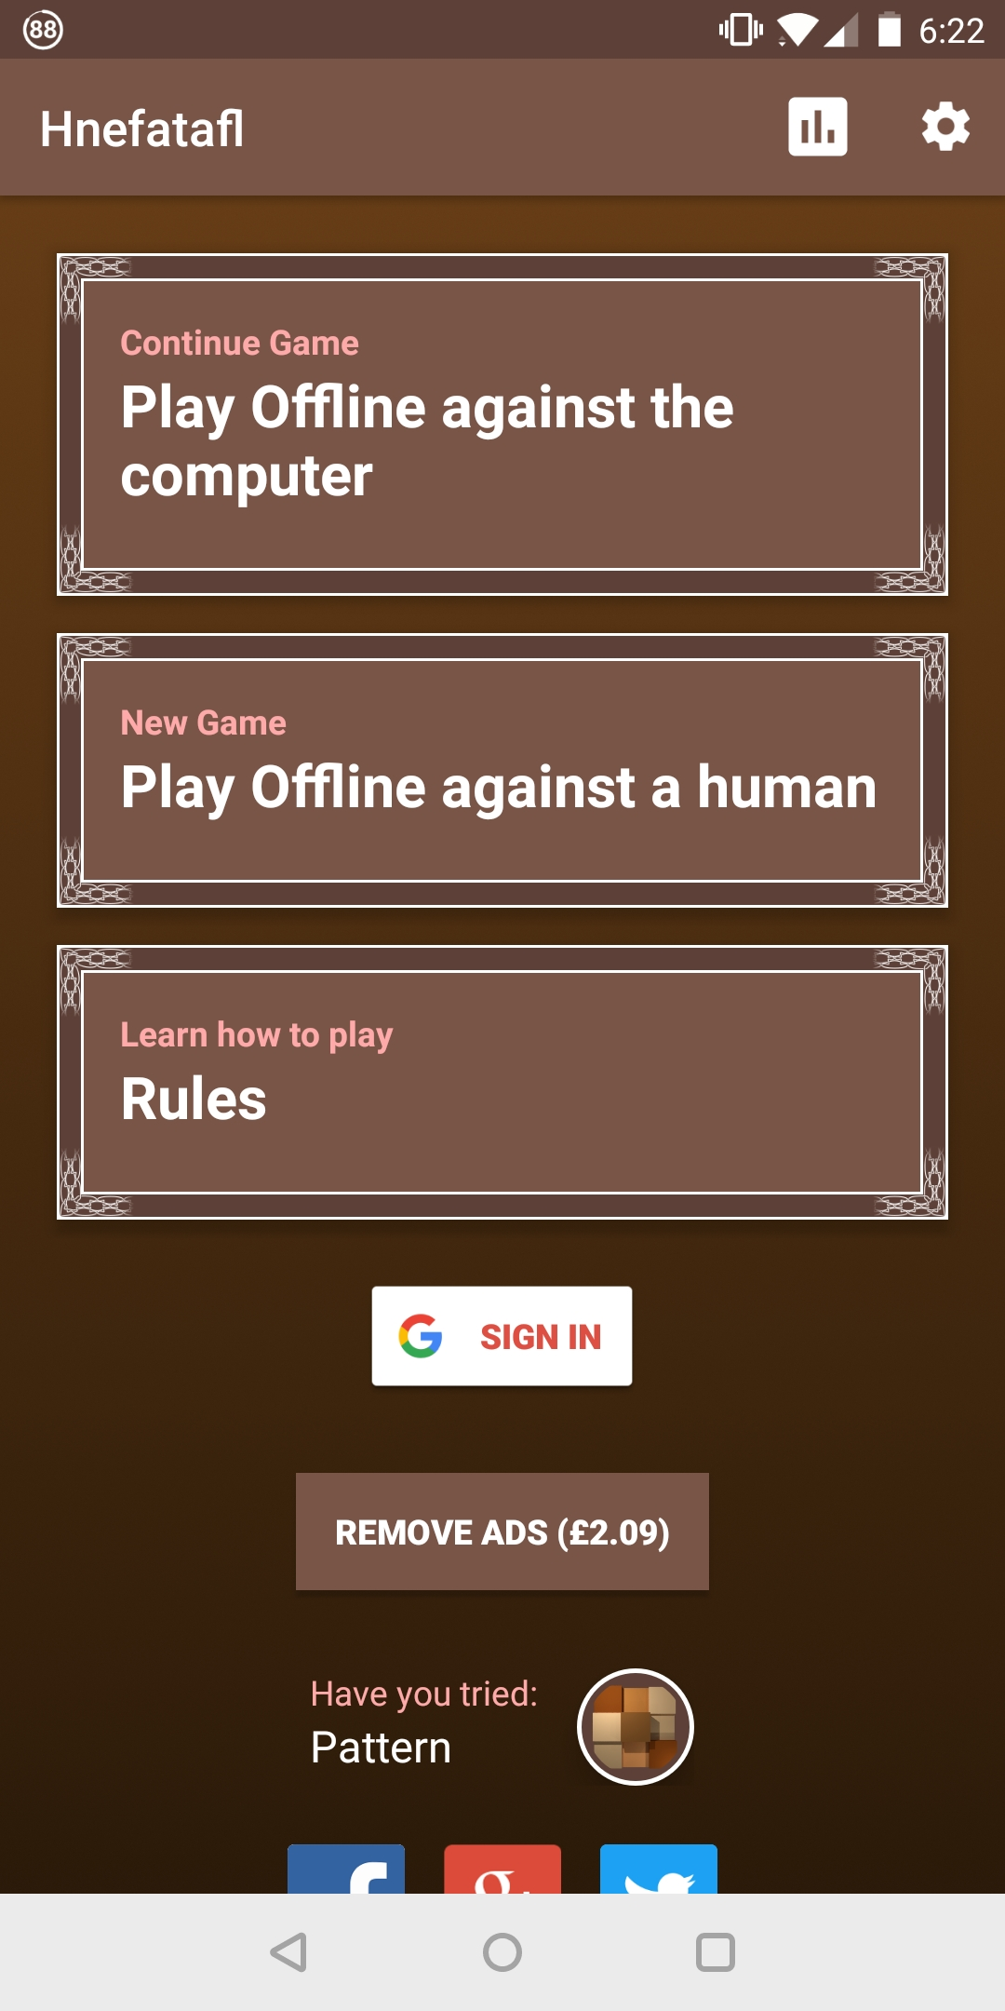

Figure

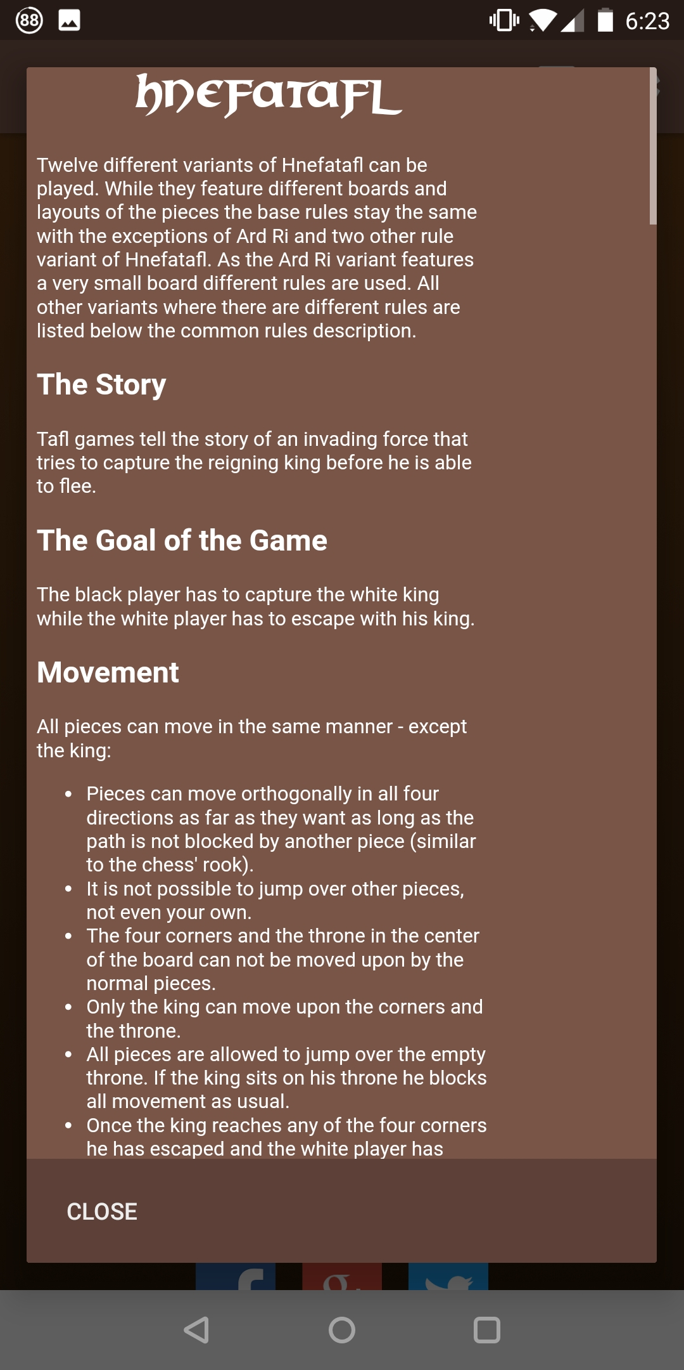

Figure

Figure 3 shows visually the user interface is minimal and while not overly attractive it does what it needs to do providing clear options to the user, with my limited art skills this should be something I aim for in the Project.

Figure 4 is a useful feature that shows the rules of the game to the player, since Hnefatafl and other Tafl games are quite different to other games it is hard to show this visually, this may be something that I can improve on in the Project.

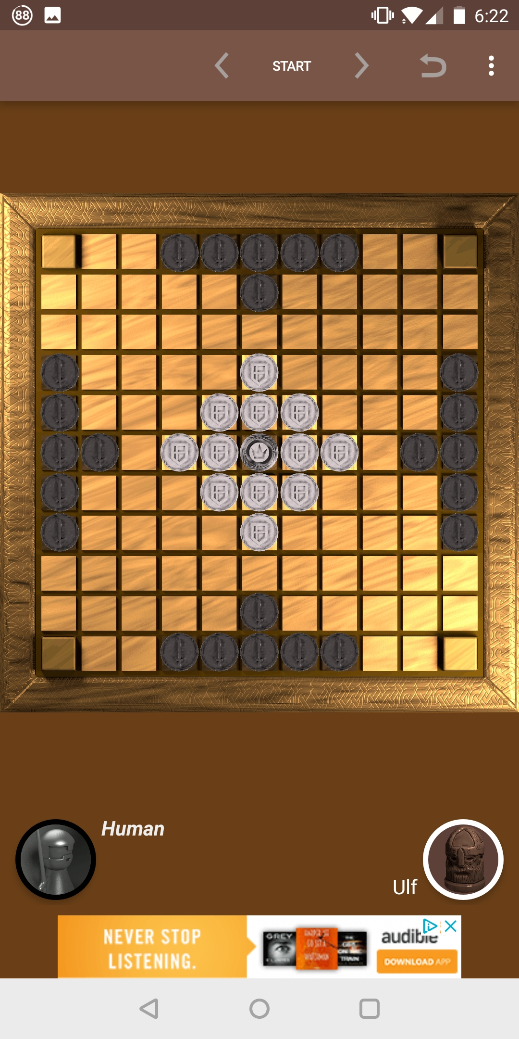

Figure

Much like the user interface this game features a simplistic board design, this can be seen in Figure 5. It does allow the user to select assorted styles of playing pieces, and this game also allows the selection of different board sizes and layouts of pieces

While the project will focus solely on the Hnefatafl version of the game, the simplistic user interface and game view could be of inspiration.

#### Tafl [3]

This game offers offline play against the computer and online multiplayer, it is unusual that is doesn’t offer offline multiplayer as that is the easiest method to implement. Much like the previously analysed game [2] this offers different layouts for the boards as seen in Figure 6. With these different board layouts there should be accompanying rules changes, but after testing out the board layout for Hnefatafl there is slight inconstancies with the other two games that I tried. These changes in the rules could be attributed to personal interpretation by the developer as the game itself has many different variations and origins. The project will stick to the most commonly established rules as this will be easier for inexperienced users to pick up and returning users of the system to know the rules straight away.

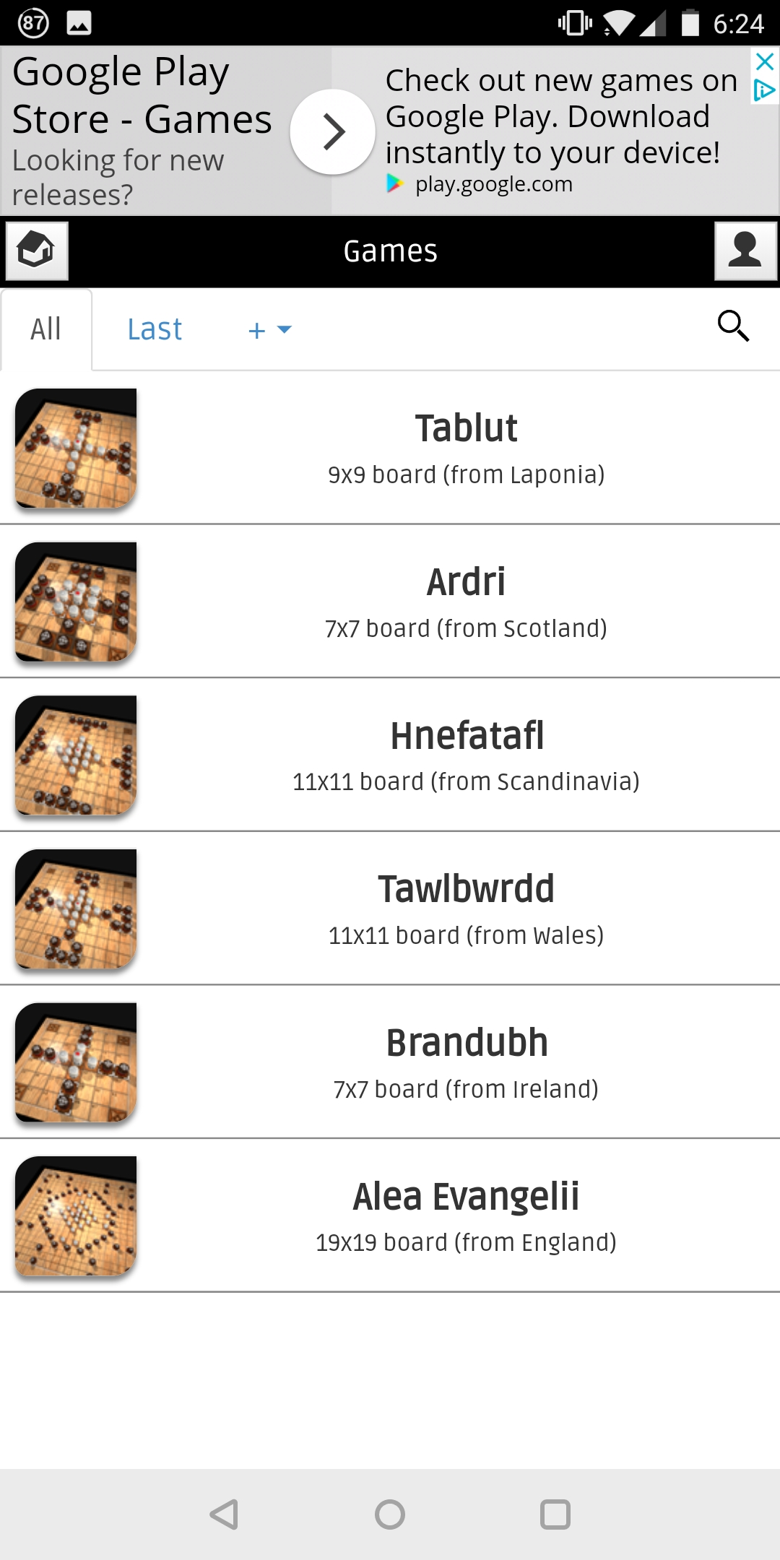

Figure

The user interface when starting a game (Figure 7) is a bit confusing, and does not easily show how to setup multiplayer games. The buttons for game setup should be obviously distinguishable from the other information buttons, in this case they are coloured different colours to the grey icons for other information, but their size could have been increased to improve their prominence on the screen. The image showing the game board is slightly unnecessary as we have previously chosen which board we want to use and could free up space for clearer buttons.

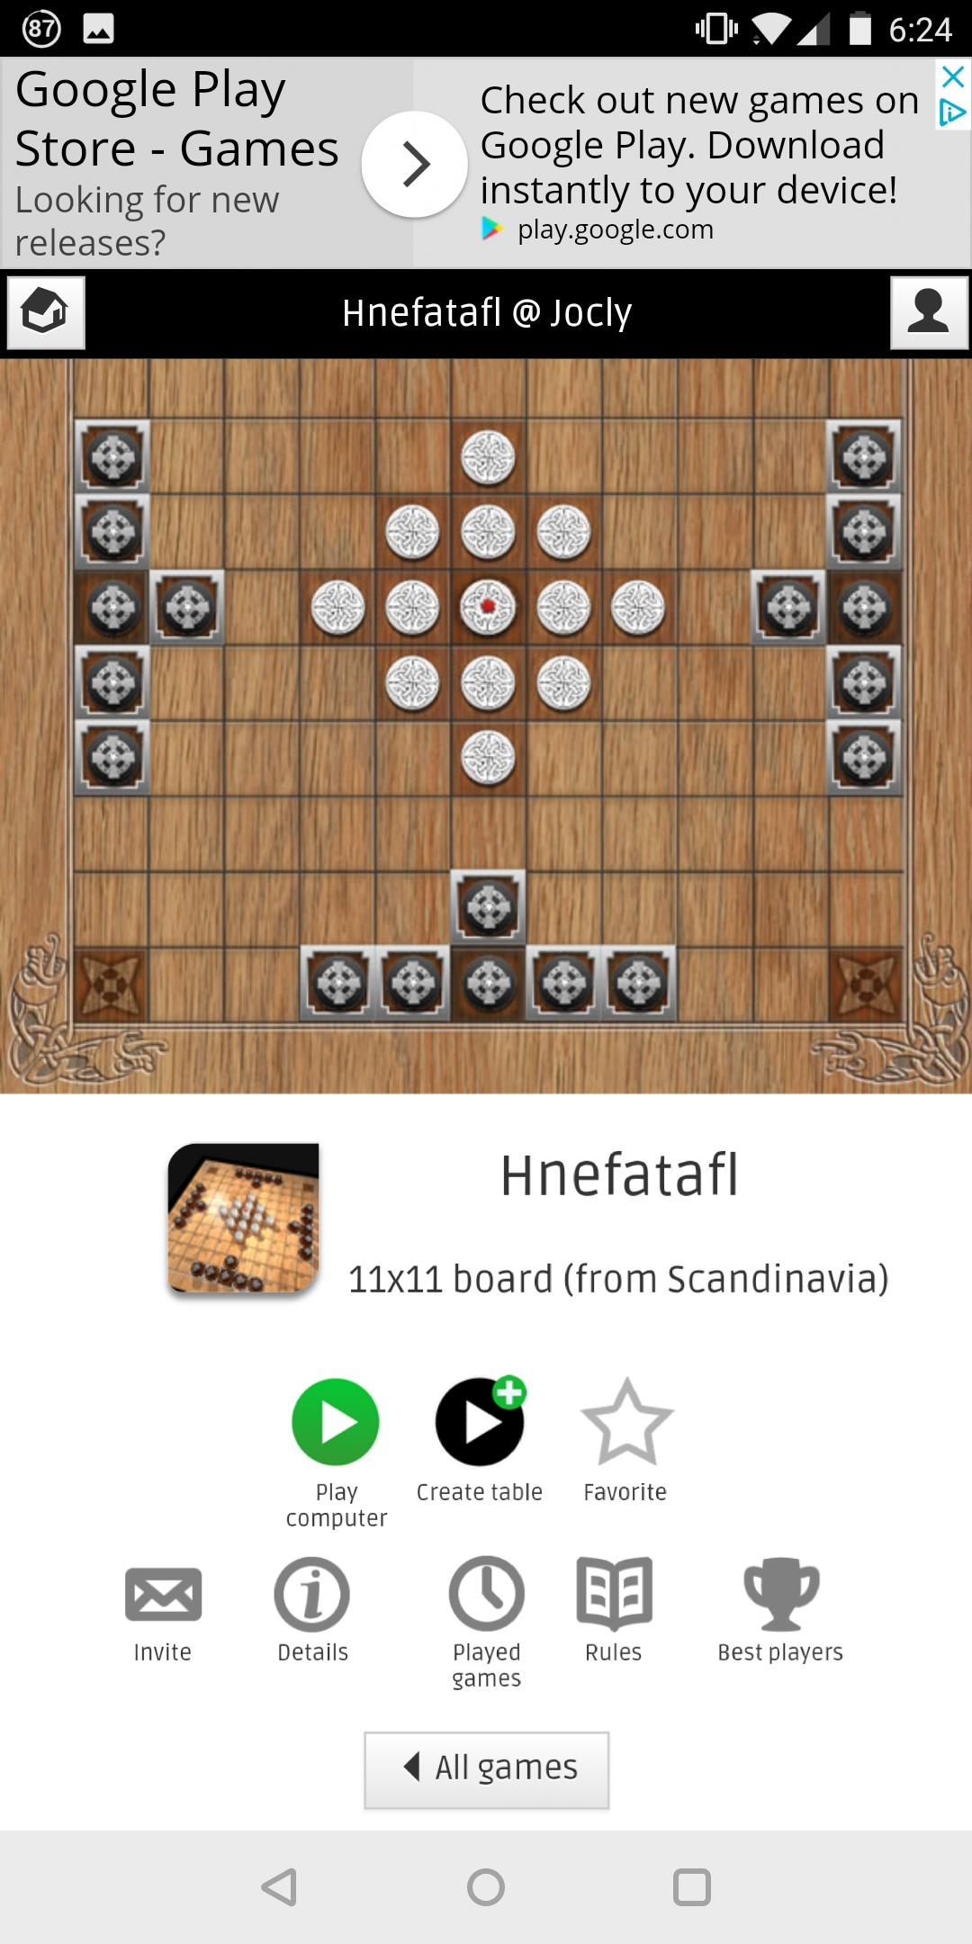

Figure

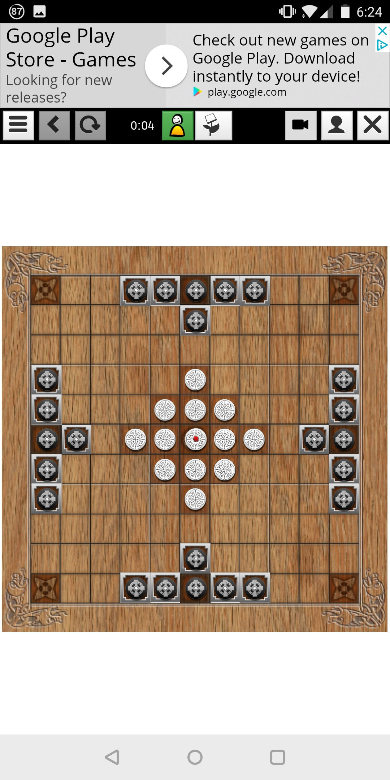

Figure

The game view (Figure 8) has the most simplistic interface compared to all the comparisons and represents the game in a classic top down 2D view. It doesn’t show any additional information including which team is starting, this can make it confusing if you are playing the computer and you have been selected to go first (which during my testing happened every time).

#### Hnefatafl [4]

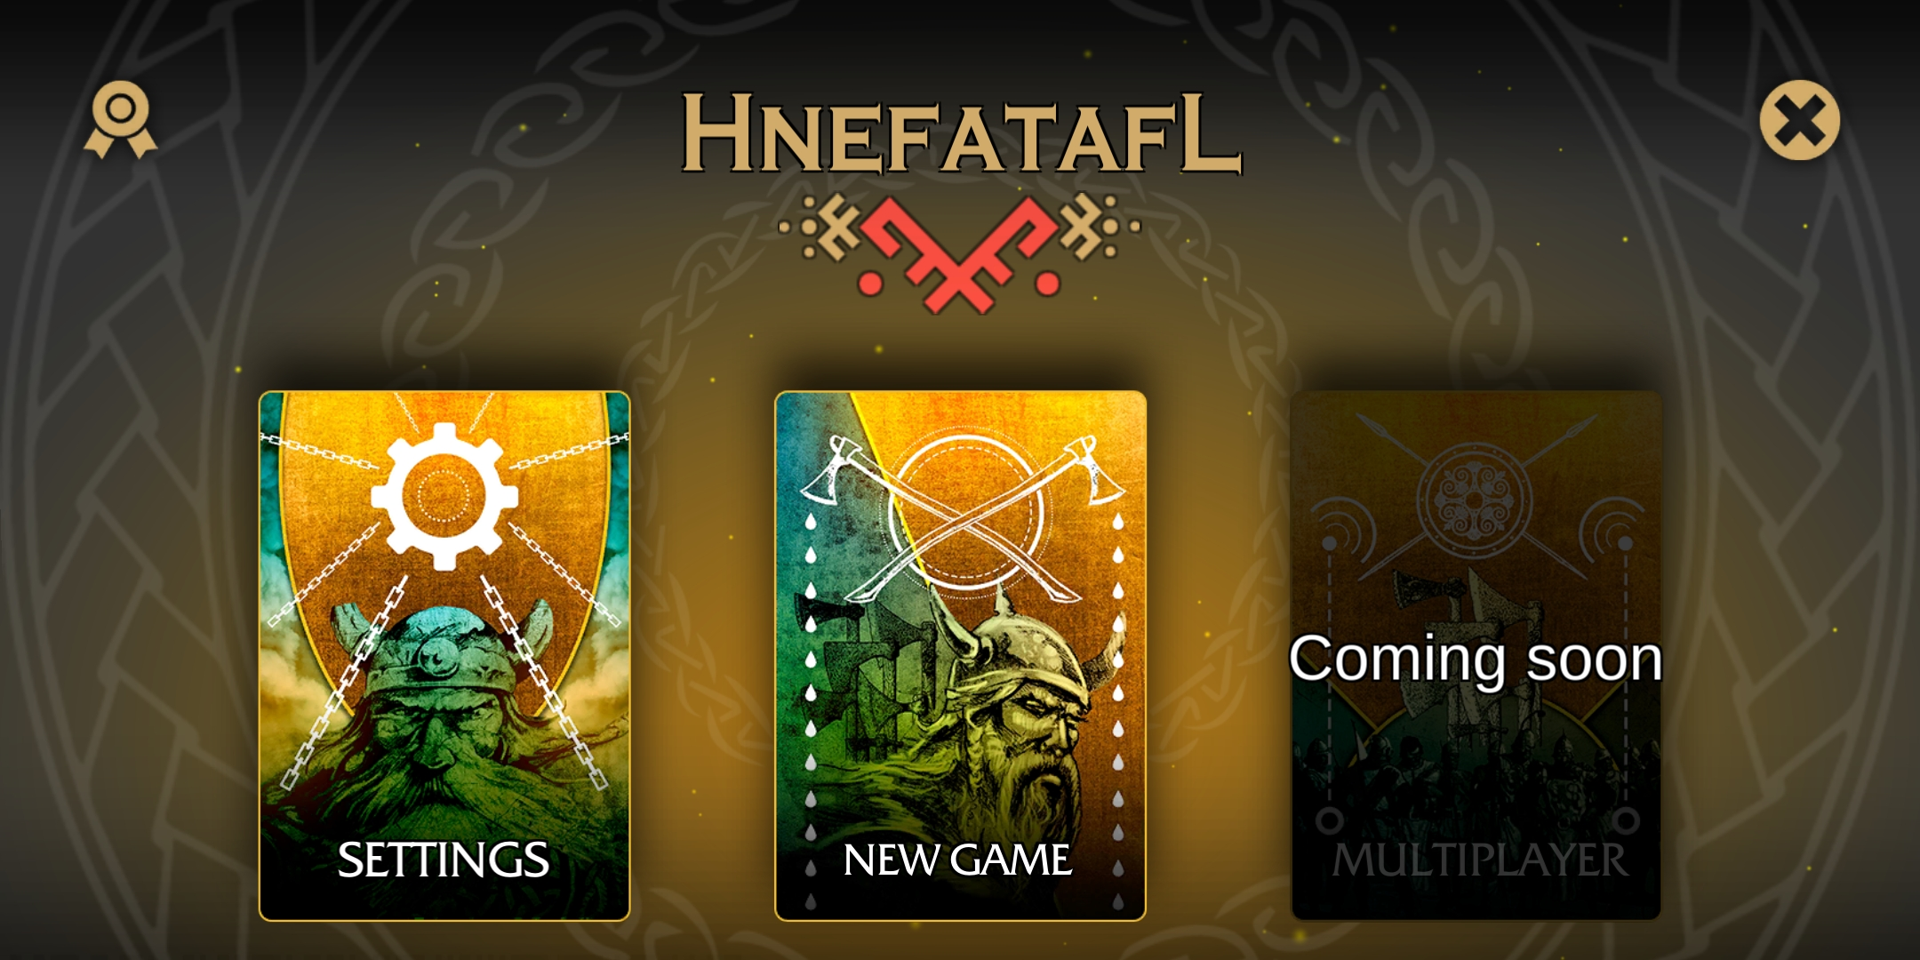

Figure

This game was by far the most graphically appealing game and a lot of effort had been put into art assets, the main menu (Figure 9) is very clean and directs the user to the main aspects of the game. Interestingly the game was made with the same game engine which the project is going to be made in which shows the graphics and polish that it is capable of.

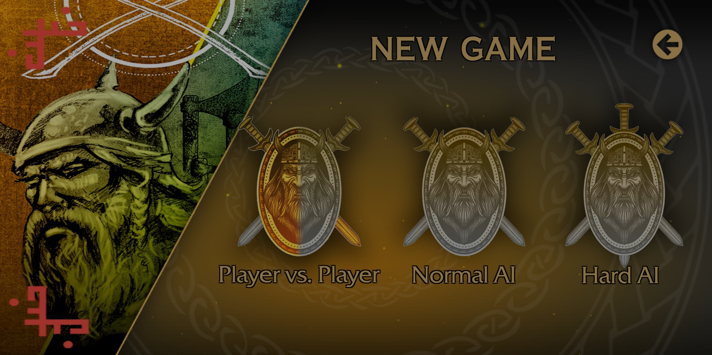

Figure

Several game modes exist in this game (Figure 10), all of them are offline currently with a grey out box for multiplayer shown in Figure 9. There exist two different difficulty levels of AI opponent which provides a small choice in opponent variety compared to [2] which had 10+ difficulty levels. The project will not focus on an AI opponent and focus on multiplayer so there is not much to learn here.

The game view is the most unique of the three games, changing styles from a 2D top down view to a 3D view with modelled game board and pieces while also implementing lighting and shaders. During gameplay on this version I noticed several gameplay choices which may have been intentional but I believe to be bugs, such as when a piece was selected at the beginning of your turn you could not then select another piece and must move the piece selected. This shows as a first-time player to the game that even small bugs can be deterring to a player and good first impressions are paramount.

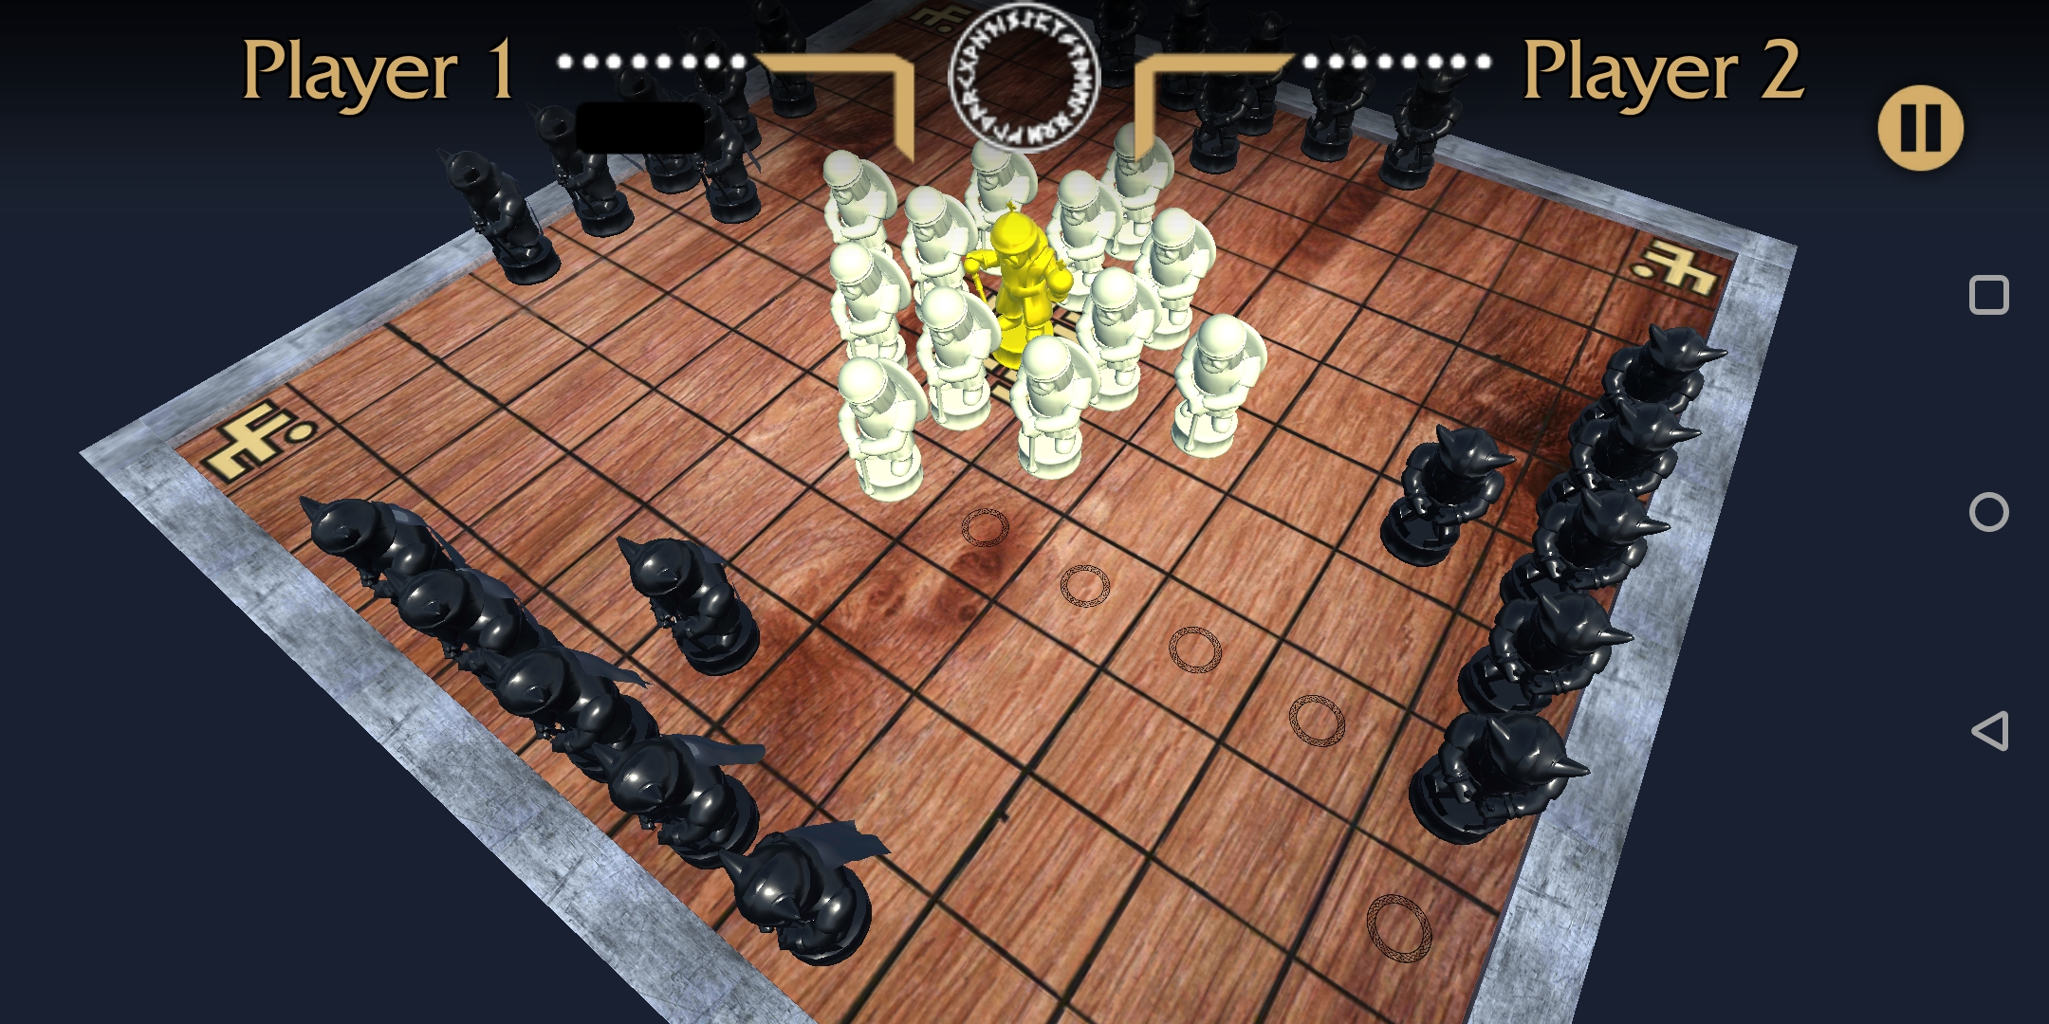

Figure

#### Conclusion of similar systems

None of the existing interpretations that I have looked at contain the exact mix of features which the project aims to bring, but it has given me the chance to study how each one implemented their version of the features that will be included. Online and offline multiplayer will play a big part, unfortunately there is only one game with functioning multiplayer but all of them features offline multiplayer for me to look at. Graphically the style that stood out the most was the one used the least, and makes a static board game feel the most interactive.

### Development Research 762

For the project there are several different technology choices that must be made as they will be the key tools used during development, changing any of these during the project could possibly require starting the entire project again.

#### Unity

Personally, I have developed basic Android applications using the Unity game engine so this was the immediate choice when deciding how to implement the project. Having previous developed in Java this was a possibility but even when using a framework such as the one provided by Android Studio the amount of work to develop certain features for example, a 3D environment is already provided and objects can be placed with in the world, as well as a built in shader and lighting system.

The choice to use Unity, allows easy exporting of the project to a wide variety of platforms. Java would also allow the ability to run on many different systems, but they require the JRE (Java Runtime Environment) to be install, Unity provides native builds for each platform that it is exported to, this means they can run it without the need to install extra software.

#### C# or Java

Developing the Multiplayer server will be one of the most technically challenging parts of the project, the language to develop it in then is very important and must be chosen carefully. The two languages that are in consideration are C# and Java, syntactically these languages are practically identical and some code can literally be copied from one to another, their main difference is in how they are run.

Java being an interpreted language requires the JRE (Java Runtime Environment) to be installed on target machines, there is some associated performance overhead because the code must be executed and converted to machine code at runtime. C# on the other hand is built by a compiler into an executable binary, this typically can only be run on a Windows but due to the language being developed using the Common Language Interface (CLI) specification [9] it can be run on several other systems.

The two languages are very similar and besides the target platforms there are no other major differences between the two, for this project it will be easier to develop in C# as the scripts used in the Unity Engine are in C# and code can be shared across applications to speed up development.

#### TCP vs UDP

When implementing an online multiplayer system there are different networking protocols to consider, TCP (Transmission Control Protocol) and UDP (User Datagram Protocol). They are both different methods of transferring data packets across a network, each with contrasting features to the other.

TCP is considered to be the slower but more reliable protocol [11], it achieves this by sending each the packets with reference to the order they were sent it, e.g. packet 1 has a reference of one, packet 2 has a reference of two, etc. This allows the receiving machine to know how to order the packets and if any have been lost, if a 2 arrives before 1, it will wait until it has 1 and then process them in order. This is where the speed can decrease, if many packets are arriving out of order then it will take time to wait for the correct ones to arrive. Even worse can be if a packet does not make it at all, then the client must send a request for the missing packet to be resent which creates more overhead.

Conversely UDP does not have any built-in ordering and unlike TCP all of the packets do not follow the same route to the target machine either. If a packet finds a faster route than the packets that left before it, then it could arrive before they do. This is when errors can occur with out of order packets, unless a method of ordering the packets has been implemented then they will just be processed as they arrive, even if they are early.

UDP is more suited to a real-time application where you need the data continuously sending across the network and can afford some data loss with the trade-off of speed. TCP even with its drawback of increased overhead when needing to request packets to be resent, it can guarantee that the packets will arrive and that none of the data is lost. The project will be implementing a turn based system for the game, therefore a real-time solution is not needed. The user will never noticeably experience the difference between TCP or UDP so the most reliable protocol will have to be used.

## Analysis 463

Using the background research, the project could take rough shape and provide some criteria to follow and what would be produced at the end of the project.

To allow more time to develop the key defining features of the game client, the Unity engine was decided to be a better choice over making the game from scratch in Java or even using the Android Studio to provide some support for Android. Using Unity will allow for exporting the game to Android and Windows from within the engine and not require any laborious process to get the game built for both, thus allowing for quick turnaround when testing builds and fixing bugs.

Having studied the art styles of the other applications available, simplistic menus allow for a more understandable user interface that doesn’t overwhelm users with lots of options immediately. The main menu should be just a couple buttons leading to the different game modes and a button to display the help screen, when in the game view, the board should not be obstructed and useful information such as, who’s turn it is and how many pieces from each side have been taken should be displayed in an unobtrusive manner.

In the similar applications the majority opted for a simple top down 2D view, this was easy to use but didn’t provide an immersion. Seeing tiles on a board is not as aesthetically appeal as physical models that move along the board using animation. The game client the project will develop will use the Unity engine to full advantage and leverage its 3D capabilities including lighting and shading.

Through the research I had looked at games that implemented a combination of online multiplayer or an artificial intelligence opponent (some with varying difficulty). Both features are a large undertaking and only one would be achievable in the time frame, while also including offline multiplayer and a respectable level of polish. Due to personal experience previously developing an online multiplayer server using the Unity game engine, the project would include an online multiplayer mode.

The online multiplayer server would have to be designed as an application separate to the main game, to allow it to be run on a remote machine. Through my research of the best programming language to use out of the two chosen had no clear winner, this meant C# was selected due to it also being used as the scripting language in the Unity game, allowing the sharing of network code and several classes. The server will also be using a TCP connection to transfer the data between clients, this is a slower (relative to UDP) but more reliable connection and will allow for packets to arrive in order so that turns do not go faulty because of out of order packets.

### Requirements 511

With the research and analysis done the items that will be produced for this project will include:

#### R1 Windows and Android Game Client

It will be the same game but released and built for two different platforms, they will remain playable and relevant to each platform through different techniques.

##### R1.1 User Interface

The Unity engine provides several user interface components these can be scaled in a variety of manner, using a scaling method that keeps the UI anchored at set points on the screen allows for lots of different resolution devices and even older aspect ratios. There will need to be a main menu for selecting game modes, as well as a help button which will bring up a screen showing visually how to play the game. When playing the game, it is good to know how many pieces have been taken so the game will keep track of this and display it for both users on the user interface.

##### R1.2 Sounds

To make the game more engaging sounds will need to be used to provides the users actions with more weight, buttons on the user interfaces should have a satisfying click sound so that it is apparent when they have been clicked. During the game different sounds should be played to indicate different actions such as, Vikings winning, Barbarians winning, Vikings taking a piece, Barbarians taking a piece and whenever a piece moves but nothing is taken. This will all provide the user with extra information in case they miss what happened visually.

##### R1.3 Help Menu

The help menu will have to explain all the rules of the game so that inexperienced players will understand how to play, because the game is not that common there is a large likelihood that the majority of user downloading the game will not have ever heard of the original. To explain the rules, they should be presented next to screenshots of the game re-enacting the scenarios being described.

##### R1.4 3D View and Scrolling

In the game view the game board and pieces will be represented in a 3D view, with the board being able to turn and zoom in and out. The pieces will be represented by models which shows the difference between pieces, Vikings, Barbarian and King. Using lighting and shaders the game should look attractive but not be too performance heavy that it detriments the user experience.

#### R2 Multiplayer Server Application

The server will allow users to connect and be added to a queue of waiting players, which should be having players taken from the front of it to pair up and send in to games. Once two players have been paired up they will be given a game ID and communication between them should begin. The server acts at the middle man between the two clients and passes the game board between the two, this way the clients never receive any data from each other and keeps the system secure. Once a game has finished they will both be returned to the main menu of their client, where they may queue back up for another match.

## Process 290

For the project I chose to take on a Feature Driven Development ethos, for a single developer with a set time frame this allows for development that focuses on the key features first. When developing a game there are many features that can be added and the danger is to continuously keep adding extra features that may not directly progress towards the final product. Polish features such as attractive user interface and sounds while not necessary do provide an increased user experience so these need to be prioritised higher than normal, so that the game still gives a good impression.

Using the deliverables as a basis, each one had their key features listed, these would determine the main points to focus on. Main priority was to develop the offline multiplayer first on the game client as this set out most of the game code that could then be used in the online version. The online server application took second precedent due to it requiring a functioning game client to be useful, there was a point in the project was it may have been necessary to stop work on the server as it may have not been finished in time.

The user interface was a key component that would normally have been finished towards the end of a project, but because of the short time frame it was prioritized alongside the multiplayer server. There was going to be a point where the server was going to be stopped because the user interface had an estimated development time and the server was very close to cutting into that time, which would have led to neither being finished. Fortunately, the server was completed within its estimated development time so both features were finished.

To record the progress and keep regular backups of all aspects of the project, version control software will be used and updated frequently. During development

# Design

## Overall Architecture 74

The project is split into two distinct components, the main game clients which will features two different modes and a multiplayer server which will allow for communication between multiple clients for online games. Both components are going to be written in C# which allows for them to share some code when it comes to the networking communication between them, there will be at least one object that will be the same on both sides.

## Feature List 353

The Feature Driven Development process that has been chosen means that a list of features should be compiled and ranked in level of importance, this will be the feature list, as programming develops the features should be taken of this list in order of importance. If it is realised that a feature needs to have it priority changed then this must be done to allow the program to be the most functional by the project deadline.

The importance values that were decided are ‘Low’ for a feature that is not vital and will not massively change the project, ‘High’ for a feature whose exclusion will be noticeable and ‘Imperative’ a feature that is required for the project to meet the major requirements.

|  |  |  |  |
| --- | --- | --- | --- |
| Task ID | Task | Importance | Estimated Time to Complete |
| 1 | Offline Multiplayer – One of the key features of the game, this allows two people on a single device to play against each other. | Imperative | 4 weeks |
| 2 | Online Multiplayer – The other main feature of the game, two players can play against each other over a custom server. | Imperative | 4 weeks |
| 3 | Animations – when pieces move, they can be animated to slide to their new locations to add to the visual effect the game provides | Low | 1 week |
| 4 | Audio Effects – When certain actions in the game take place audio should be played to enhance the user experience. For example, when pieces are moving or taken and when UI elements are clicked. | Low | Less than a week |
| 5 | Visual Effects – When pieces are selected they can change colour to visually show this, the 3D view can contain post processing effects to make it look nicer. | Low | Less than a week |
| 6 | User Interface – Even though a basic user interface will be mandatory an attractive user interface will heighten the user experience and make the game more enjoyable to play. | High | 1 week |
| 7 | Multiple Board Sizes – allow for the user to be able to play on more than just the standard board size, this will require creating a new layout for all pieces. If more than two board sizes are implemented this could be made easier with an algorithm. | Low | 2 weeks |

## Detailed Design

### Game Client

### Server Application 60

The server will be made in Visual Studio as a WPF (Windows Presentation Foundation) application, this will provide a user interface for the server operator to interact with. The server will act as a middle man between clients and will pair them up for games, during a game the board state will be passed between the clients through the server.

There will be a log manager in the server that will handle all the messages that it receives, this will be output to a visual display on the user interface and also to a text file. The log text file will allow the server operator to read back through the log when an error occurs, for this to function effectively messages must be located all over the program to be output. Whenever a try-catch block is used the resulting error will need to be output to the log because these will be most of the errors that may occur

### Network Code 97

In both applications there will need to be some shared code to allow the networking to function, this was one of the main factors when choosing to use C# for the server programming.

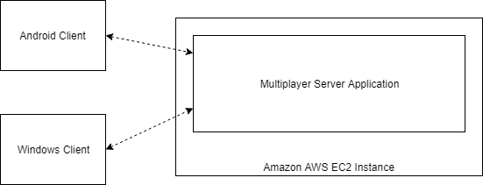

Figure

Figure 12 shows an overview of how the online system will work, clients will communicate with each other through the server application. The server will be open to the internet and will continuously accept connections from clients. The game client will be published for both Windows and Android but they will be able to communicate with each other allowing cross platform play.

#### Network Loop

Figure 13 shows how the interaction between the client and server should function. The server will continuously run listening for incoming connections from clients, once a client has attempted to connect it will be added to a queue of waiting players. The player will have to wait until there are at least two people waiting and then the server will pair them up, this is treated as a queue and theoretically could have lots of people waiting if the server is overloaded but realistically as soon as it has two users they will be taken out.

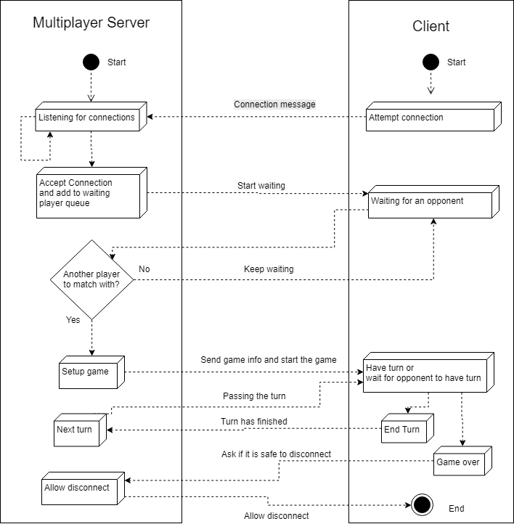

Figure 13

#### Network Message Object

To help transfer information between the server and the client a class will be used on both sides, this will provide a common structure for sending and receiving messages. Both programs will be using C# so this class will be identical, it will contain methods to convert an object into a string representation and a method that can convert a string into an object of the class.

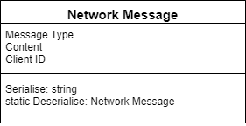

Figure

Figure 13 shows the variables that the class will contain, the Message Type will be a custom Enumerator that will be used to choose how to handle the message when it’s received. The Content variable will just be a string and will not always be used, when messages are sent to connect, disconnect, find a game they will not need to transfer any content. The main time the content will be used is when the transferring the board state between players during a match, the game board will be converted into a series of coordinates and piece types this will then be converted to a board on the receiving end.

## User Interface Design

### Game Client 504

The user interface for the game client should be simple and useable on a touch screen because it will be running on Windows and Android devices, for this purpose large buttons are useful. There will only need to be three buttons on the main screen, one will take the user to offline multiplayer, another will transition to online multiplayer search and there will be a help button to show the user a screen in which they can learn the rules of the game.

Unity engine provides a drag and drop method of creating user interfaces and has many settings to customise elements that are put on to the screen, an important feature that will help with developing for Windows and Android is UI Scaling. There are different settings for how the user interface should scale on different size devices, the best method for the projects application will be to scale each element to scale with the screen size [20].

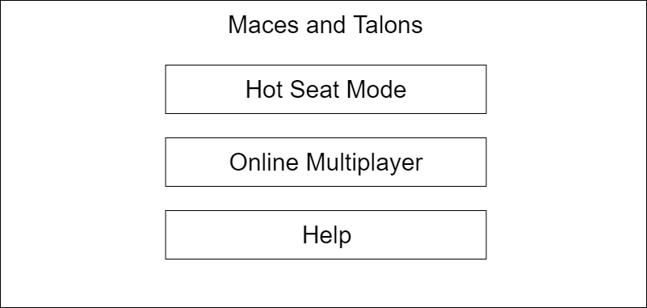

Figure

Figure 13 shows a brief design of the planned user interface, the three buttons take up most of the screen for easier clicking. This could appear quite large on Windows computers so a different version may need to be created to fit better on a larger screen, but using the Unity scaling it will make it still work on many devices. For Windows devices there would probably have to be a button that allows the user to exit the application in case they are running in full screen mode.

When the user selects offline multiplayer both players will need to select which team they want to be on, this screen (Figure 16) will have radio buttons for each player to allow them to choose their team. Using radio buttons, when one player selects a team the other player should automatically have the opposite team selected. Having a system in place to stop both players having the same team selected will stop their being any errors when trying to move to the game. When the play button is clicked the players will be taken to the game view, unless somehow, they have the same team selected in which case they will be told to pick different side, or if neither have selected a team.

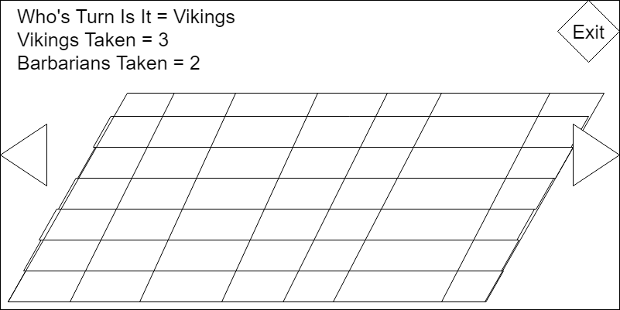

Figure

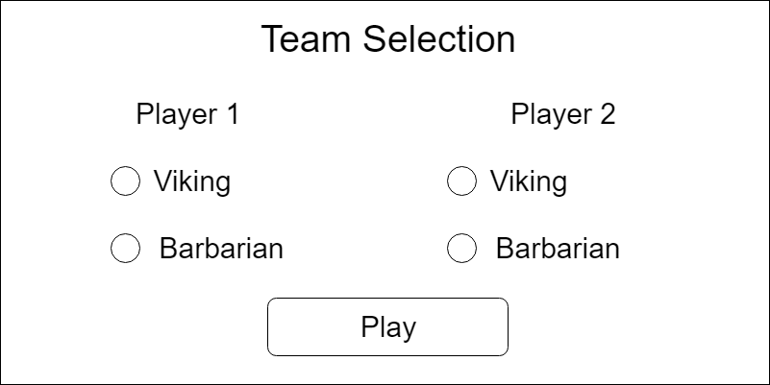

Figure

The main game view (Figure 15) will be where the actual board game is played. Most of the screen will be taken up by the board and pieces, players will select pieces from their team and move them around. To get a better or different angle of the board there will be buttons to allow the board to rotate, this will give a different vantage point for the players to select their pieces and movements. Information will be displayed to the users, such as who’s turn it currently is and how many of each side have been taken from the game. There will be a button that will allow quitting to the main menu at any time, this will not save the state of the board.

### Server Application 151

The server application’s user interface will show information that will be useful to the operator and such as how many clients are connected and how many games are currently being played. Figure 15 shows an example of the layout that would be used, it shows the log manager and how it will display different messages related to the operation of the server. If anything goes wrong with the server the messages in this log could be useful and as discussed in the server design, they will be saved to disk as log files.

Unlike the game client there will be no other screens for the server to display so implementing this on the server will be not require much time. One of the tools that will be used is Visual Studio 2017 [18], this provides a graphical editor for creating user interfaces and will allow rapid development of the server UI.

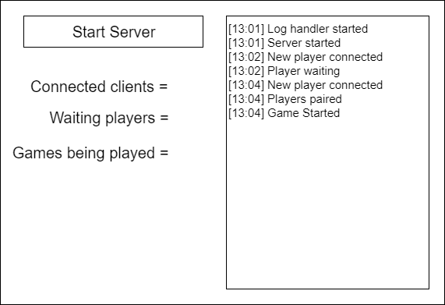

Figure

## Mid-Project Design 207

During development of the project there were aspects that had been overlooked or had not been address in the original design phase, it was then necessary to plan how these features would be structured. This was not a concern because the Feature Driven Development process that the project was following allows for iterative planning and implementation.

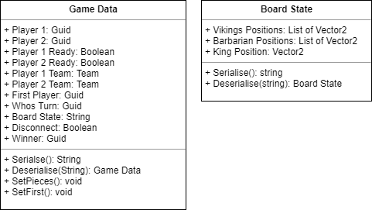

Figure

Figure 16 shows the two main classes that had to be designed for use on the server and the game client, they will help with formatting data about a game being played between two clients and allow the server to attach appropriate data to the package such as if a player has disconnected. Being able to tell a player whether the other player has disconnected or won the game will allow their client to display relevant messages and then leave the game view.

The Board State class is needed to convert the positions of all the pieces on the game board into a series of coordinates and piece values separated by a value which can then be taken out such as a ‘/’ (forward slash), the server will never have to handle the board state it just needs to pass it within the Game Data in its string representation.

# Implementation 2298

## Game Client 108

Most of the games client’s implementation followed the design very well, there was some user interface changes once testing had been done and better ways were found to create it. Originally when selecting a team in the offline mode there were going to be drop down boxes where the two users would select which side they were on, this felt unnecessary and for only two selections was inconvenient. It was therefore changed to be a set of buttons that toggle the other players team when one person selects a team, this kept the two teams opposite and no problems with both people selecting the same team was possible.

### Game generation 267

In both the offline mode and multiplayer mode there is quite a lot of code that is reused, the offline code was implemented first but with the aspect that it could be used later for online. Everything is separated into classes, which allowed for easy modification and creation of child classes when making the online multiplayer code.

Originally at the beginning of the design phase there was the possibility of including more than one size of board, because Hnefatafl can be played on a 11x11 or 13x13 board. This meant that an algorithm was designed to allow a board of nth width to be generated if n is odd, Figure 15 shows code that was used to make sure that n was odd.

if (size % 2 != 0)

{

width = size;

height = size;

}

else

{

Debug.Log("Error that size is not an odd number");

}

Figure

To go with the board generation, pieces are generated into their position as well, this is where the limitation of board size was introduced. The 11x11 board was created first and the pieces are setup specifically for that board type, to create the board a class was implemented that creates the physical tiles. A reference is kept in the main game class so that when pieces move to a new tile it can be checked to see if it is a corner or throne tile. When the board size was going to be variable this would have allowed for checking to still work because the corners would move, a rigid coordinate system wouldn’t have made this work.

### Taking pieces 190

A large technical part of the code was detecting when pieces had been taken by the other team, the location of pieces are stored in a two-dimensional array that represents the game board. From this the game can detect where a piece is in relation to other pieces, this allows for quick checking.

During the development of this code there were lots of out of bounds problems, due to some pieces on the edge of the board. When a piece is checking is it has been taken it looks at all four of its sides, initially this meant that a piece on the edge of the board would try to check a space that didn’t exist off the edge. Four checks had to be added depending on which edge of the board a piece was on, that allowed the algorithm to skip the empty space. What made it harder was that normal pieces (Vikings and Barbarians) can’t be taken by a theoretical enemy in the space off the edge, but the King can, which meant that different code had to be used for checking if the King had been taken.

### Selectable Pieces and Movement Tiles 468

Making a piece selectable was made straight forward by Unity, the engine has a feature to detect which point on the screen the mouse is over and can also detect screen input. Using an event function ‘OnMouseOver’ whenever the user is hovering over the desired piece they can click or press the screen and the game will checking if that is a piece that may be selected. This is a section of code that had to be modified when adding the multiplayer aspect, the game reuses code for both offline and online. If it is an online game the Network Manager needs to be referenced and the team can be accessed, if the game is offline a simple toggle is used to just flip between team when one makes a move.

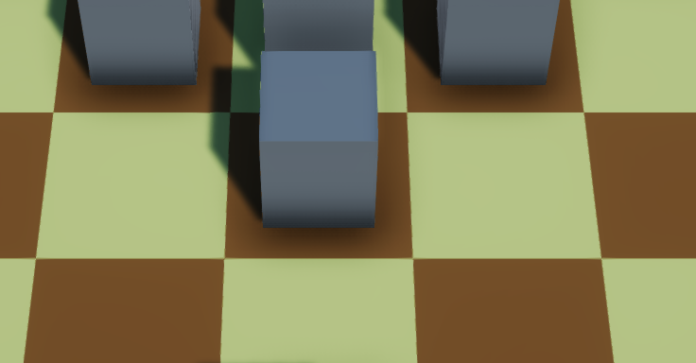

Figure 16

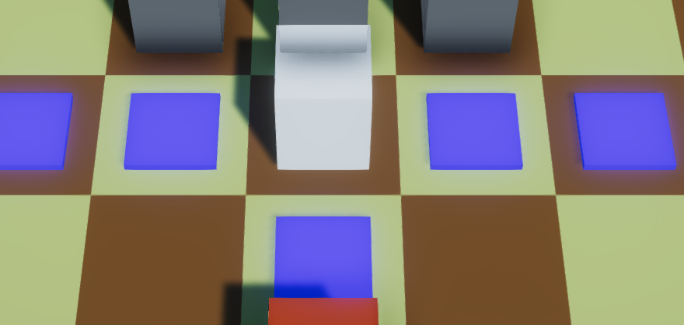

Figure 17

To show the user whether they have selected a piece the game changes the colour of the piece, using a Unity Store package MK Glow Free [1] this provides a variety of custom shaders for use in a game without having to spend time understanding how to create custom shaders. When used the piece looks like it has been lit up when selected, Figure 16 shows a piece that has not been selected and Figure 17 shows the same piece that has now been selected. When planning out how to show the piece selection other methods such as changing the colour of the tile the piece is one were considered, however they did not stand out as much as lighting up the piece.

Once a piece has been selected, it needs to move. This is achieved by generating tiles for the user to click when a piece is selected, by then clicking on these tiles the piece will move to the selected location. To generate these movement tiles the game must check what possible moves can be made by the selected piece, there were several problems with this feature. When pieces were being moved they were not correctly changing their location in the array representation of the game.

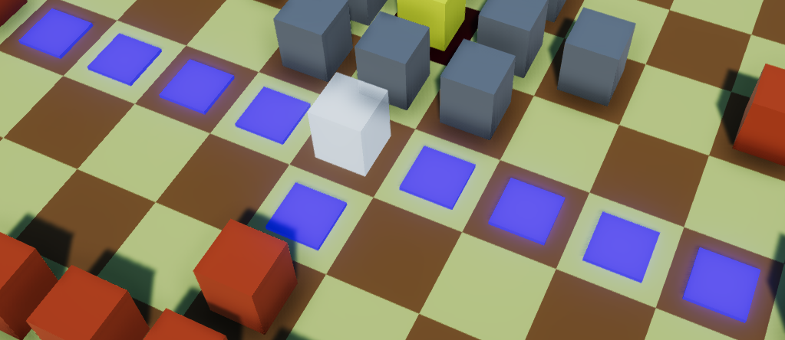

Figure

The board can be thought of in two ways, there is the graphical representation that the user sees and the code array that’s stored the locations of the pieces. If the two representations do not get updated together it can lead to problems and bugs, this happened when the graphical level was changed so the piece had appeared to move but in the code, it was still at its original location. This meant that when another piece looked like it could move over a tile that was previously occupied it couldn’t, because the space was technically still occupied. It took a while for the source of this problem to be located, but once both representations were in sync the movement functioned correctly.

## Multiplayer Server 138

There are two versions of the server, one provides a graphical user interface while the other operates in a console window. These two versions provide the exact same features to the clients, they only affect the information shown to the operator of the server.

The graphical version uses WPF (Windows Presentation Foundation) forms to create a look that is identical to most of standard Windows applications, this provides features that allowed the creation of a real-time log that output the messages the server is handling. A couple of displays will also show the number of users connected to the server and how many are waiting for a game. The console mode has no graphical user interface and just displays the real-time log in the console as messages get processed, otherwise the functionality of the server is the same.

### Setting up games 197

When a user connects to the server they are placed at the back of a waiting queue, this contains all the clients currently waiting for a game. When the queue contains two or more clients, two are taken from the front and a game is generated. The server then randomises which team each player will be and who will go first, this is all added to an object that stores a reference to all information about the game (the players, who’s turn it is, whether anyone has won, if a player has disconnected).

Once the game has been setup on the server the clients are informed that a game has been found and the game is transferred to the client, they will know whether they are first by reading the game data and checking the first player with their own ID, if they match then they will be going first.

To play a game the clients send the state of the game board in the message when passing the turn, this is then relayed by the server and the next client replaces the pieces in their game with the new positions of the pieces that it received.

### Server Hosting 298

When testing the server during development it could be run on the same machine as the test clients and connected to using the machines local IP address. However, when larger testing needed to happen over the internet it had to be deployed to a server, it could have continued to be run on a development machine but opening it up to the internet would not be ideal for security reasons.

A better solution was to upload it to an existing server hosting service which would increase security and allow for a more reliable uptime that didn’t rely on the development machine stay powered on permanently. The hosting service chosen was an Amazon AWS EC2 container which provides a free tier with low performance, but with the size of testing that would occur during this project this was sufficient.

Initially a Windows server instance was used but unfortunately the free tier of EC2 did not have enough performance to run the operating system, let alone the server. A Linux had to be used instead, however this lead to its own problems because the existing server application was designed to run on Windows. The original application would not run on Linux, fortunately C# can be run on Linux using the Mono library [15] (a cross platform .Net framework). Mono allows C# programs that do not use any Windows specific features like WPF (Windows Presentation Foundation) forms or WinForms (Windows user interface libraries). To create a server that works on Linux all of the WPF elements had to be stripped from the existing server application, this was easily done by creating a completely new console application then transferring the necessary code to the new application. The new application works well on the free tier of EC2 and can handle multiple connections.

## Network Code 67

Some sections of the code that makes the online mode work is shared across the server and client, combined with the use of C# in both implementations this allows for a robust system that allows message to be sent over the network. The server implements some features that allow it to authenticate the messages the client devices send and uses a system that will enable large scalability.

### Network Message 177

The main class that defines a message between the server and client is the Message class, this defines values for the message that needs to be sent, user id, client id and the type of message. When a message is sent from the server there will not be a user id associated with the message because that is only used when authenticating a client message 3.3.3.

This message class provides the ability to convert an instance of the class to a string representation to then be transferred as a series of bytes over the network, this is the serialise method. When a message is received it must be converted back to a message object and this can be done statically through the user of the deserialise method, this will take the string and split it up into the variable components then convert them back into the types that they were previously in. Using this method of serialising and deserialising it is possible to maintain a standard way to convert the message on both the server and client.

### Connection and message types 244

The connection type used by the server is TCP allowing for messages to be ordered and more reliable connection, the way this then operates on the server is through a multithreaded asynchronous connection. The server is constantly listening for new connections from a client, when a device attempts to connect the server adds the client to a list of connected clients. The game client generates a device id to that is maintains while the game is open, this is stored as a GUID (Globally Unique Identifier). GUIDs are a large 128 bits value that has a practically infinite number of combinations, there is an insignificant chance that there will be two clients with the same GUID [14].

Microsoft has examples for ways to setup server code, the initial code used to make the server client connection work code from one of these examples [13]. This code then had all unnecessary features stripped from it and it was also simplified, it used several different methods that could be combined and simplified to make the code more readable. Once there was a basic server client infrastructure implemented messages could be sent back and forth using the message class. One of the values stored in the message is a message type, this is used to determine how to handle the data that has been sent in the message. Through use of these message types a large switch statement allows for handling the messages and send appropriate response.

### Authentication 144

The server authenticates user messages in a couple of ways, first using the message class and using a combination of ids. If a message is sent to the server and it doesn’t correctly deserialise into an instance of the message class then either the message is corrupt or the message was not sent from an official client.

Once a message has been deserialised it has to then be confirmed that it has been sent from an authorised client, when a client connects it is given an id by the server this id must be sent with every message the client wants to transmit. If the client sends a message and the id does not match the servers stored value then the message is disregarded, this stops third party programs from connecting to the server even if they discover how to correctly format a message.

# Testing

## Overall Approach to Testing 107

The project used several methods for testing, first was the continuous testing of components during development as they were implemented to not allow the program to get riddled with serious bugs. Development would halt until a bug had been fixed, this process allowed for a much more successful testing at the end of the project. At the end of the project black-box testing was employed to develop a thorough check list that the features worked as they were supposed to. The final testing was User acceptance testing, because this project is a game, it is ideal that it be tested by an audience to get initial reactions.

## Black-box Testing

### Game Client 215

There are three main aspects to the game client testing, these include testing that the user interface functions correctly throughout the program including the menus and user interface. The offline game and multiplayer game will also be tested separately.

#### User Interface

|  |  |  |
| --- | --- | --- |
| **Test ID** | **Test Description** | **Expected Results** |
| 1 | Clicking information button. | Help screen is displayed. |
| 2 | Click back button of information screen. | Returns to the main menu screen. |
| 3 | Clicking offline game button. | Taken to team selection screen |
| 4 | Clicking Viking on Player 1. | Viking for Player 1 should be highlighted and Barbarian should be highlighted for Player 2. |
| 5 | Clicking Viking on Player 1 while selected. | Viking for Player 1 should become unselected and Barbarian for Player 2 should become unselected, then Barbarian for Player 1 is highlighted and Viking for Player 2 is highlighted. |
| 6 | Clicking Play while no team are selected. | Should stay on same screen and display an error message saying that no teams are selected. |
|  |  |  |

|  |  |  |  |
| --- | --- | --- | --- |
| **Test ID** | **Result** | **Relevant evidence** | **Pass or Fail** |
| 1 | Help screen appears |  | Pass |
| 2 | Main menu is displayed |  | Pass |
| 3 | Taken to team selection |  | Pass |
| 4 | Viking is highlighted for Player 1 and Barbarian is highlighted for Player 2 |  | Pass |
| 5 | Barbarian is highlighted for Player 1 and Viking for Player 2 |  |  |
| 7 |  |  |  |

#### Offline Mode

|  |  |  |
| --- | --- | --- |
| Test ID | Test Description | Expected Results |
| 1 |  |  |
| 2 |  |  |
| 3 |  |  |
| 4 |  |  |
| 5 |  |  |

#### Online Mode

|  |  |  |
| --- | --- | --- |
| Test ID | Test Description | Expected Results |
| 1 |  |  |
| 2 |  |  |
| 3 |  |  |
| 4 |  |  |
| 5 |  |  |

### Server

## User Testing 57

To test the user experience of the game, the project was promoted and a user feedback form was offered to be filled out, the form can be found at Appendix C.

Using Google Forms an anonymous feedback form was created and can be distributed via URL link, the form also provides graphs to show the responses visually.

# Critical Evaluation

## Research 46

When doing the research there was no consideration towards how the server application would be hosted, this had to be solved before wider user testing could occur. During development this could be tested on the local machine, but that wasn’t ideal for opening to the internet.

## Requirements 38

When comparing to the feature list outlined in the Design, there are several features that didn’t get complete. Fortunately, these were all low priority tasks but they would have added an increased level of polish to the game.

## Design Decisions 66

2D could have been a good idea

Using a network message class allowed for very easy transferring between server and client, the serialise and deserialise methods once implemented early on had to be changed quite a lot. The initial structure of the class changed several times through development and a few new variables were added to it the allow different interactions between the server and client.

## Testing

The testing undertaken was ok but there was more that could have been done to ensure the reliability of more of the project, as well as more tests earlier on to drive the development of the project.

Stress testing on the multiplayer server could have been done by creating a test application, this program could send many connections to the server. It would then simulate the game messages between the test clients and the server, this would see how the server can handle many connections and how much it slows down when processing multiple matchmaking pairs simultaneously.

## Tools 151

The success of the tools chosen for the project vary, using the Unity engine was the right choice allowing for more time developing the game instead of my own engine to make the game. It provided a good set of tools for developing 3D models and lighting, the user interface was easy to implement using a drag and drop system although tricky to get the scaling working for multiple resolutions.

Using C# for the server may not have been the best decision, unfortunately little thought was given to a practical solution for testing the server at the beginning of the project and Java may have been an easier option due to its compatibility with lots of platforms. A solution was worked out using the original C# project but it did have to be converted into a slightly different application as imagined getting it to work on the Amazon AWS Linux server.

## Future Work 500

If the project were to continue development there are several features that could be added or improved upon.

### Authoritative Server 127

Currently the server has no checking to make sure the board states being transferred between the clients and that the clients are making valid moves. Now it relies on the checking that has been built into the client, but if anyone modified the game client somehow or intercepted the packets being sent to the server then this would not be detected by the server.

This could be implemented by holding the board state of each game on the server, whenever the turn is passed check that only a single piece has been moved and that where it moved to is a valid location. This would however put a lot more processing on the server between turns and on the current hosting setup would probably cause performance issues.

### Online Lobby and Friends 79

Now the only way of getting into an online multiplayer game is by being randomly matched with other people, if the game grew there would most likely be a demand for users to play against their friends. By creating a lobby system where players can create matches and allow their friend to select to play them, this would require a solution seen in many games in which a password would be needed to lock the game out to strangers.

### Google Play integration 121

This feature would only be relevant to the Android version and would drive development towards just supporting Android, this would most likely be most of the devices running the game.

Using the Google Play Game Services (GPGS) [16] the game would be able to make use of integrated leader boards and users could sign in using a Google account. Building upon the online lobby idea put forward in 5.5.2. the GPGS could also enable sending game requests to friends on your google account and sharing leader board information with them. This would all add a level of risk, because currently the server does not share any information between clients and this solution would require opening them up to their Google profiles.

### 2D View 49

After research it was decided that a 3D view would be used, but the option for a 2D view could be developed to allow the user to select how they want to play. This could allow for lower end devices to be able to download and play the game.

### AI opponent 124

When researching other similar applications, a main feature that many of them shared was a mode that allowed you to play against a computer opponent, this would be a good addition to the project and allows a user to play the game even when they have no one with them or the server is empty.

This feature would require extensive development and would possibly be an entirely separate project due to the complexity. Many of the other applications had several levels of difficulty, machine learning could allow the AI to become very proficient at playing the game much like the Google DeepMind AI [17] playing GO, it is open source and would possibly serve as a basis to create an AI for the project.

# Appendices

* 1. Third-Party Code and Libraries

**MK Glow Unity Asset *Free** – This asset provides some fancy glowing materials which I am using for selected pieces in the game. [1]

**Kenney Game Assets** – A collection of art assets, they are published under the Creative Commons Zero v1.0 Universal License. All of the buttons in the game use are from this pack. [19]

* 1. Glossary

Serialise – The process of turning a class into a series of bytes.

Deserialise – The process of turning a series of bytes into a specified instance of a class.

* 1. User Feedback Form
  2. Ethics Submission
  3. Code Samples

# Annotated Bibliography

[1] MK Glow Free –

<https://assetstore.unity.com/packages/vfx/shaders/fullscreen-camera-effects/mk-glow-free-28044>

This Unity asset provides some fancy glowing materials.

[2] Hnefatafl (Philippe Schober) (Google Play Store) –

<https://play.google.com/store/apps/details?id=com.fellhuhn.hnefatafl>

[3] Tafl (Jocly) (Google Play Store) –

<https://play.google.com/store/apps/details?id=com.jocly.android.app10_vc_as>

[4] Hnefatafl (MeatballsTeam) (Google Play Store) –

<https://play.google.com/store/apps/details?id=com.meatballsteam.hnefatafl>

[5] Hnefatafl The Viking Game –

<http://www.gamecabinet.com/history/Hnef.html>

[6] Hnefatafl –

<https://boardgamegeek.com/boardgame/2932/hnefatafl>

[7] The History of Hnefatafl –

<http://tafl.cyningstan.com/page/3/the-history-of-hnefatafl>

[8] Android Studio –

<https://developer.android.com/studio/>

An IDE and visual editor for Android applications, a possible candidate for developing the project.

[9] CLI – Common Language Interface –

<https://www.c-sharpcorner.com/UploadFile/f64127/C-Sharp-tutorial-part-2-cli-clr/>

A specification that C# was built upon that describes the way it can run and the environments it can run in.

[10] TCP vs UDP –

<https://www.diffen.com/difference/TCP_vs_UDP>

[11] UDP vs TCP – Gaffer on games - <https://gafferongames.com/post/udp_vs_tcp/>

[12] Real-Time Data Transfer –

<https://www.lifesize.com/en/video-conferencing-blog/tcp-vs-udp>

[13] Microsoft Asynchronous Socket Server Example -

h<ttps://docs.microsoft.com/en-us/dotnet/framework/network-p>rogramming/asynchronous-server-socket-example

[14] The quick guide to guids –

<https://betterexplained.com/articles/the-quick-guide-to-guids/>

[15] Mono Library –

<https://www.mono-project.com/>

[16] Google Play Games Services –

<https://developers.google.com/games/services/>

[17] Google Deepmind –

[https://deepmind.com](https://deepmind.com/)

[18] Visual Studio 2017 –

<https://www.visualstudio.com/downloads/>

[19] Kenney Game Assets –

<https://kenney.itch.io/kenney-donation>

[20] Unity Canvas Scaler –

<https://docs.unity3d.com/Manual/script-CanvasScaler.html>